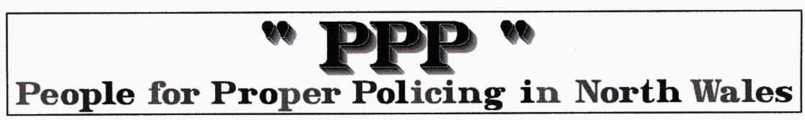
North Wales Explain 'Operation Focus'
This story from the Police Oracle website 14-Sep-09 at … http://www.policeoracle.com/

As 10,000 bikers support a newspaper campaign against the perceived police stance on motorbikes, the Police explain 'Operation Focus'....
Supt Simon Shaw added: “Because of the significant proportion of deaths and serious injury collisions involving motorcyclists we are constantly working with our partners to reduce injury and save lives through engineering, education and enforcement.

“The vast majority of motorcyclists we encounter are law abiding but there is a hardcore minority who are determined to use our roads as racetracks and in doing so have and continue to put themselves and other road users in mortal danger.

“We will continue to target, with a view to prosecution, all those that ride or drive dangerously, at excess speed, overtake on solid white lines or commit any other road traffic offences.”

2 former police officers who ride motorcycles and were stopped, 'engaged with' and had their documents checked by police as part of 'Operation Focus' have contacted 'Police Oracle'.

One former officer, a woman, stated "I got a lecture about casualty figures which I didn't really need. I know the officers were only doing their job but having acknowledged that I was not a criminal and that my bike and my riding were completely legal, the officer who interviewed me insisted that he needed to do a PNC 'Wanted/Missing/Disqualified' check on me. I know that the force has a difficult job reducing the casualty figures but they need to target their efforts at the idiots. They are not difficult to spot."

The other former officer stated "The officers were very polite and professional and were just doing their job. I know the police powers and had no problem with being stopped or the manner of the officers involved however I do question the tactic. The officers were on rest day overtime from an ANPR team, operating without the ANPR cameras. Surely the purpose of the ANPR system is to identify suspect vehicles and riders before stopping them - thereby using scarce resources to best effect without inconveniencing the law-abiding public. I was stopped while riding very slowly and lawfully in very heavy traffic.

"While the officer was speaking with me a clown 'popped a wheelie' in heavy traffic going past the road check point. The response of the officer was "we've no chance catching these idiots today" which was a fair and reasonable assessment of the situation, leaving me to again question the tactic. I'm just not convinced that the police are helping their own - very good - case. After earlier success, I suggest they now should consider re-focussing Operation Focus."

The PPP comments ….these two Motorcycling ex Police officers state the obvious response of reasonable people whether Motorcyclists or not to this NWPF policy. We repeat that officers like Shaw are in Denial and continually use emotional blackmail to excuse their unacceptable activities. In so doing they have corrupted the other emergency services into doing likewise. IT IS REALLY TIME FOR A CHANGE.

